27-7-2023 PMKY ASSIGNMENT FILE

1/23/FET/BCS/083 – AMAN SHARMA

**Step-by-Step Guide to GitHub Account Creation, File Sharing, and Branching**

# **GitHub Account Creation**

**STEPS**

1. Open GitHub Website.
2. Sign Up.
3. Choose google account.
4. Sign in.
5. Enter a username.
6. Solve captcha.
7. Verify your mail.
8. Log in to your account.

# **File Sharing on GitHub**

**STEPS**

**FORKING A REPOSITORY**

* Search for any topic (python in our case), a list of multiple public repositories on the topic will appear. These Repo’s contain projects related to the topic.
* Choose any of them and click on the fork option in the menu.
* This will create a clone of the repo in your repository.

**DOWNLOADING AND USING GIT**

* Go to git download and download it.
* Once installed open “git bash” terminal.
* Now enter the commands:

1. LOGIN

$ git config –global user.name”AMANXLIGHT”

$ git config –global user.mail”AMANXLIGHT@gmail.com”

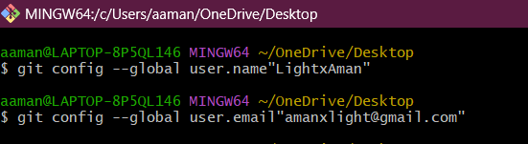

1. Create a local repo on your device

$ git init PMKY1

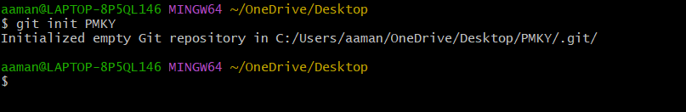

1. Downloading a clone to the forked repo

$ git clone URL

1. To add a file in our cloned repo

$ git add Filename

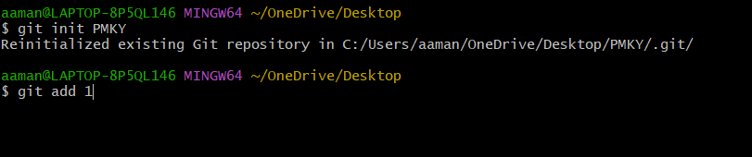



1. To commit a message

$ git commit -m " Commit Message"

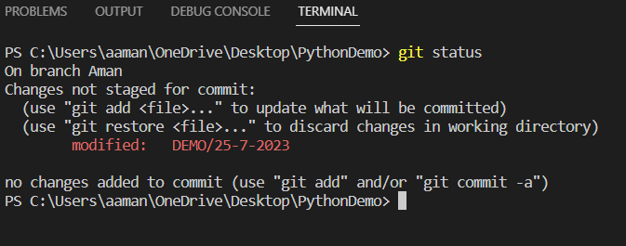

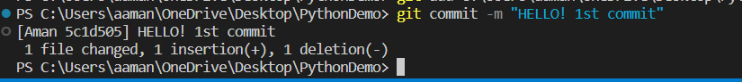

1. Now PUSH the changes

$ git status

# BRANCHING

1. BRANCH command

$ git branch

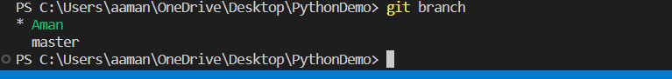

1. MERGE branches

$ git merge BranchName

$ git status